**EXPERIMENT 3**

**Aim:** To perform the various Clauses in sql.

**Software Used:** MySQL

**Theory:**

**ORDER BY:**

The ORDER BY keyword is used to sort the result-set in ascending or descending order. The ORDER BY keyword sorts the records in ascending order by default. To sort the records in descending order, use the DESC keyword.

**GROUP BY:**

The GROUP BY statement groups rows that have the same values into summary rows, like "find the number of customers in each country". The GROUP BY statement is often used with aggregate functions (COUNT(), MAX(), MIN(), SUM(), AVG()) to group the result-set by one or more columns.

**HAVING:**

The HAVING clause was added to SQL because the WHERE keyword cannot be used with aggregate functions.

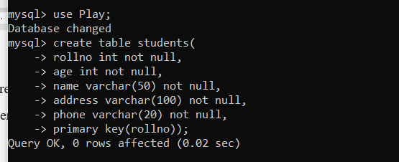

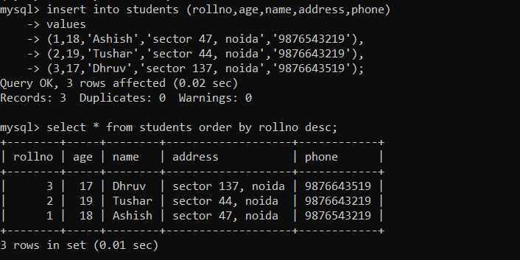

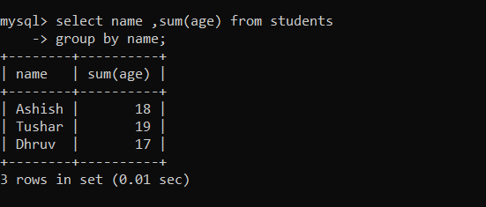

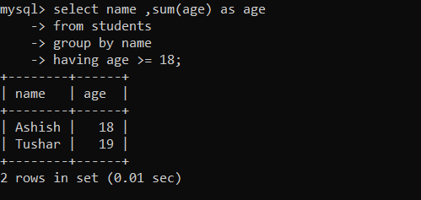

**Conclusion**: Performed the various Clauses in sql